Which is better: Splinting the MCP or PIP joint when managing Trigger Finger?
Teo, S. H., Ng D. C., Wong, Y.K.(2018). Effectiveness of proximal interphalangeal joint blocking orthosis vs metacarpophalangeal joint blocking orthosis in trigger digit: A randomized clinical trial. Journal of Hand Therapy, 1-7.
The Skinny- This study compared PIP joint immobilization via an Oval-8TM with a custom MCP blocking orthosis in the treatment of trigger finger.
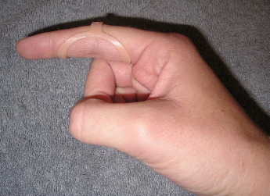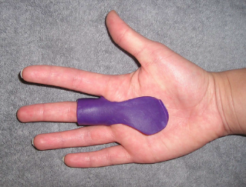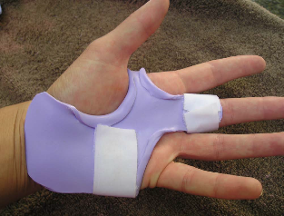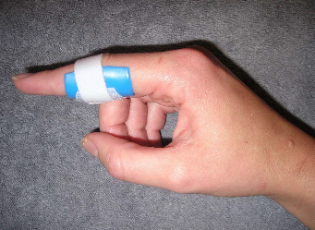
In the Weeds – Patient (n=35) with Trigger Finger (n=43) were analyzed. Twenty-three patients were allocated to the PIP joint splinting group and 20 patients were in the MCP splinting group. Patients wore the orthosis for eight weeks.
Pain reduction was observed in both groups, but pain reduction was greater with PIP joint splinting compared to the MCP joint splinting group. There was only significant improvement in QuickDASH for the PIP splinting Group. Patients wore the pip joint splint significantly longer during the day compared to the MCP splinting group, most likely due to improved comfort.
Bringing it Home- Findings suggests both orthoses are effective in reducing QuickDASH scores, reducing pain and improving overall trigger finger symptoms based on Green’s Classification. However, the pip joint immobilization splint was better for improved function and improved compliance.
Rating (0-5 ) - Small sample size. All patients with comorbidities were excluded limiting the generalizability of finding. Immobilizing the PIP joint compared to the MCP allows more function and improved compliance. When immobilizing the MCP you limit intrinsic grasp which is a necessity for function. The authors recommend wearing the orthosis for weeks duration for 24 hours in order to reduce triggering symptoms.

